厦门迪太进出口有限公司
XIAMEN DITAI IMP.& EXP. CO.,LTD
地址：中国厦门禾祥西路鸿升大厦8A
8FL, Hongsheng Building, West Hexiang Road, Xiamen, Fujian, China
TEL:0592-26808108 Phone:+8615160094689 FAX:0592-2680880 E-mail: irene.zhang@xmditai.com
----------------------------------------------------------------------------------------------------------------------

Ammonium Molybdate Heptahydrate CAS 12027-67-7

Ammonium Molybdate Heptahydrate CAS 12027-67-7 Product Description

Ammonium Molybdate Heptahydrate CAS 12027-67-7
Product name: Ammonium Heptamolybdate
Molecular formula: (NH4)6Mo7O24·4H2O
Physical and chemical properties: Ammonium Molybdate Heptahydrate CAS 12027-67-7 is White/white with light green crystalline powder, insoluble in ethyl alcohol, the solubility is more than 60g in room temperature.
Quality Standard: Mo 54.0% Min

Ammonium Molybdate Heptahydrate CAS 12027-67-7 Packaging & Delivery

Packing:25/50kg in fiber drum /woven bag with inner double layers plastic bag.
Delivery Detail: 20 days after order confirmation
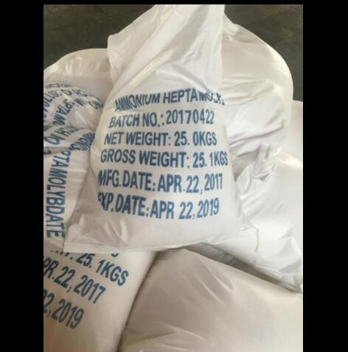

Ammonium Molybdate Heptahydrate CAS 12027-67-7 Applications

Ammonium Molybdate Heptahydrate CAS 12027-67-7 is the important reagent for mensuration of phosphorus, best choice for the manufacture of cyanoethylene catalyst.

